**Assignment 9 & 10**

**Individual Assignment - Visual Analytics**

**Anshita Thakkar**

Dashboard #1

Worksheet #1 - Treemap

Worksheet #2 – Bar chart

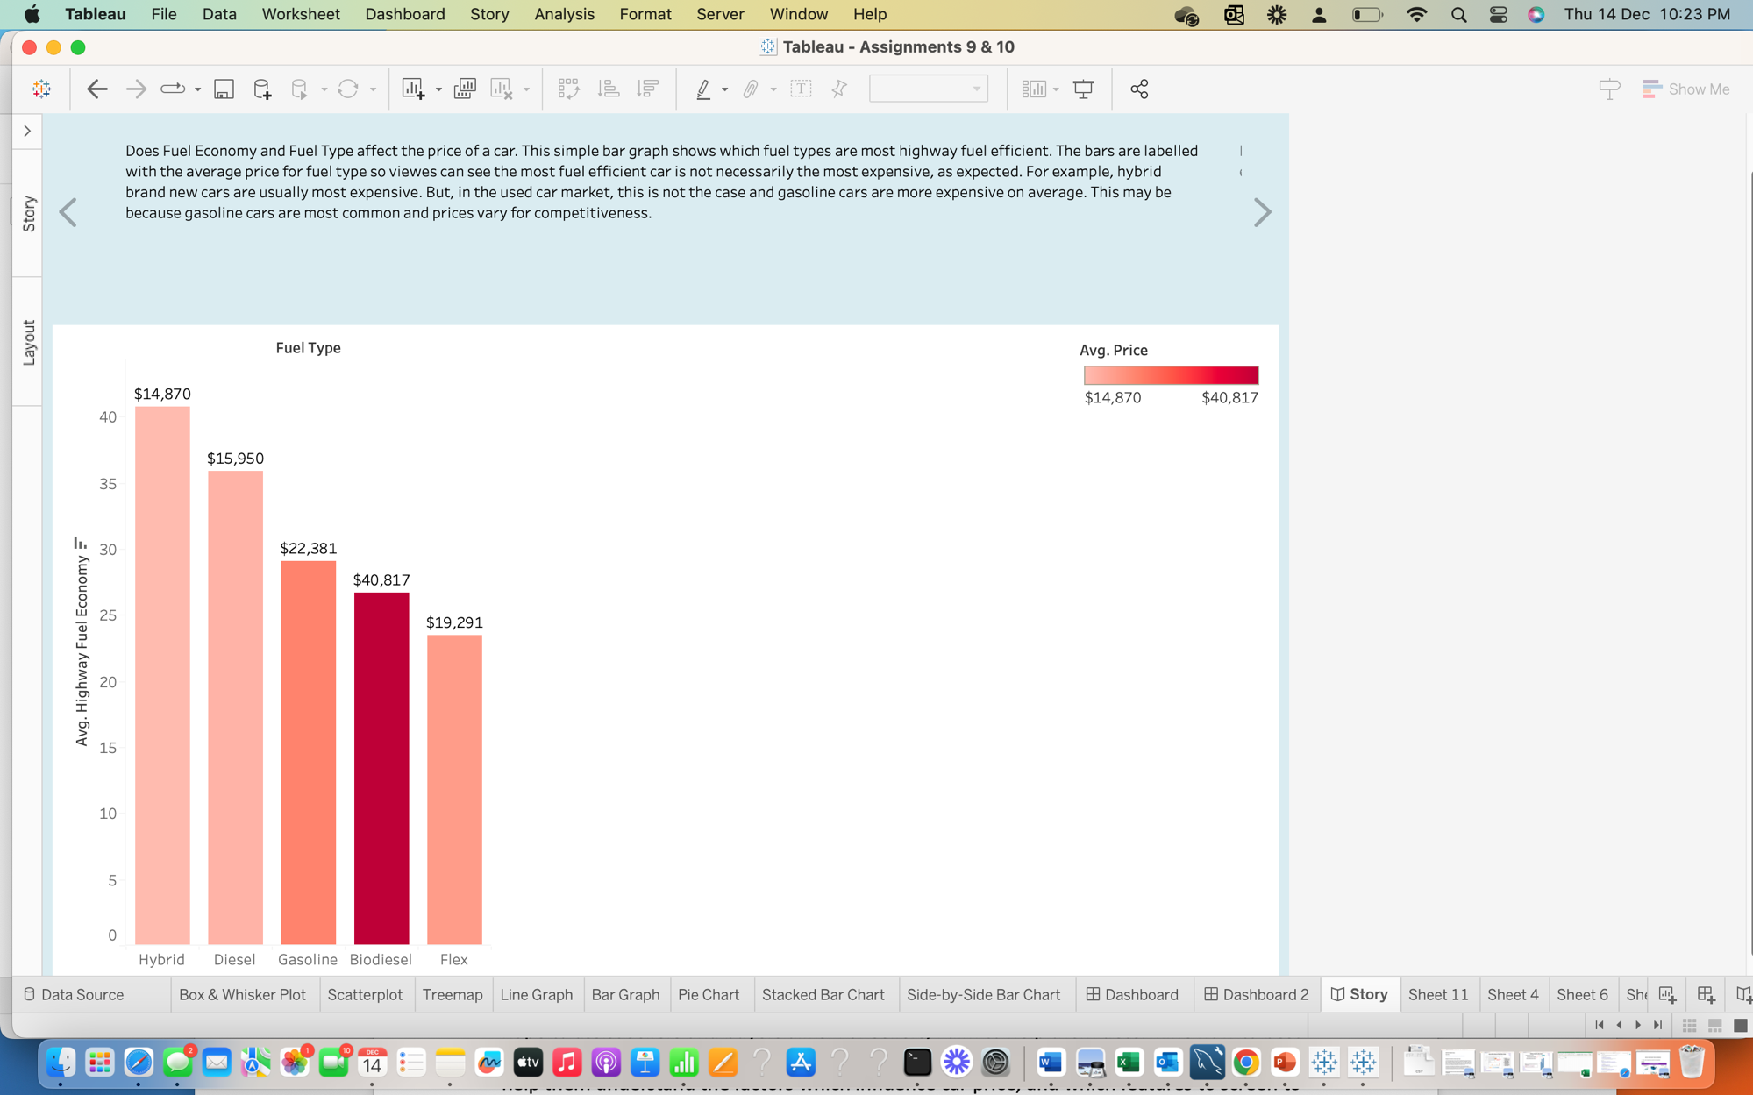

Worksheet #3 – Pie Chart

Worksheet #4 - Bubblechart

Worksheet #5 - Scatterplot

Worksheet #6 – Focused scatterplot

Worksheet #8 - Boxplot

Worksheet #9 – Side by side scatterplot

Worksheet #10 – Line chart

Dashboard #2

